*Video Timestamp*

[*https://youtu.be/osQjStOAci0?t=2h27m41s*](https://youtu.be/osQjStOAci0?t=2h27m41s)

Project README and Log – Orbital- Jeremy Hon and Adrian Chan

Project Title: Cycle of Life

# README

**Overview:** We aim to create a text based narrative driven game. Players will begin playing as a child who has been abused by his parent.

Our ignition slide:

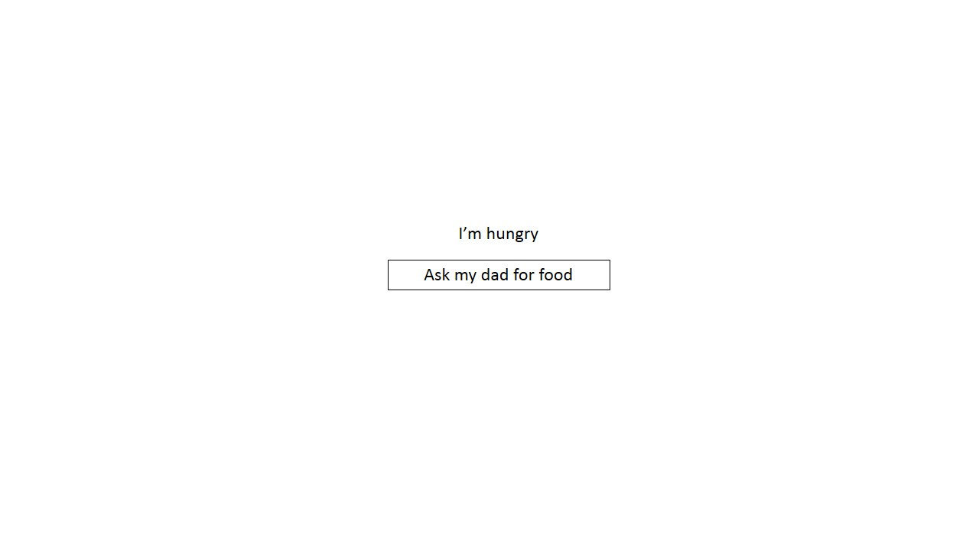

YouTube link to our Ignition presentation:  
<https://youtu.be/osQjStOAci0?t=2h27m41s>

**Planned Features:**

We hope to create an interface that allows players to keep track of the individual statistics (i.e. age, happiness etc). We also hope to create events that the player will have to experience. And from there, create additional choices which players can take that will affect the character. Furthermore, as the character grows up, we hope to introduce a parent-child system where players get to play 2 characters simultaneously, allowing one to interact with each other.

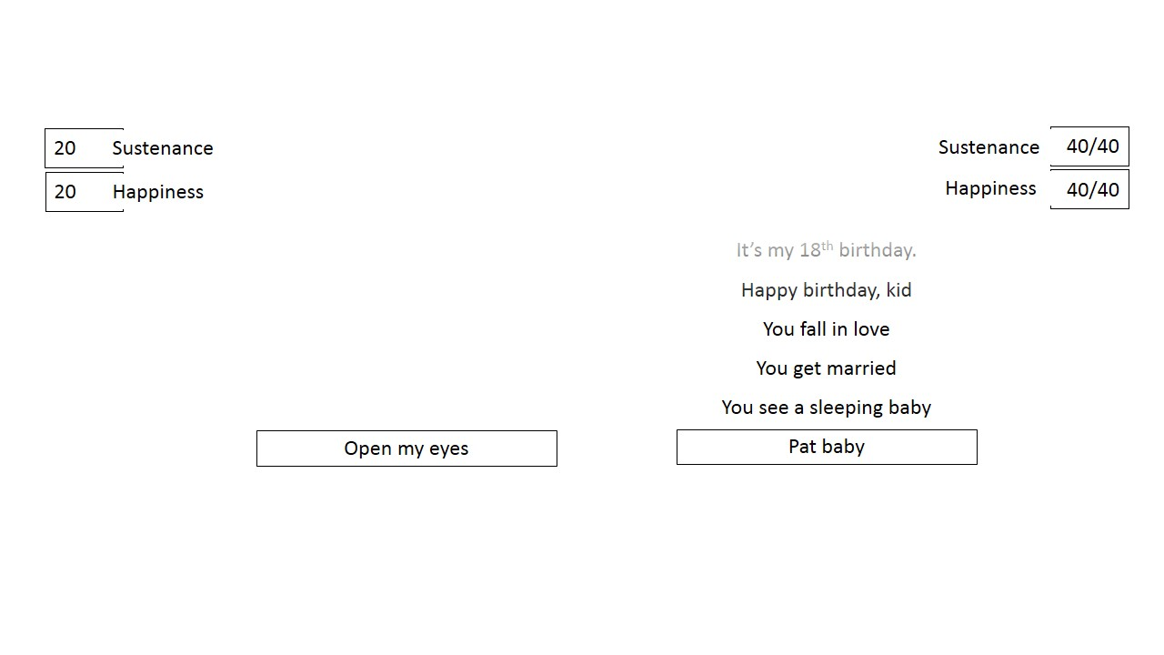

Below: The full interface which players will eventually experience. More features could be included once we have achieved

**Proposed Level of Achievement:**

We believe that we are able to achieve Project Vostok(Beginner) level of achievement. We have both attended and completed Liftoff and attended the bootstrap workshop(something which we are using in our game development).

# Project Log

**Total hours for Jeremy Hon: 37**

**Total hours for Adrian Chan: 28**

|  |  |  |  |  |  |
| --- | --- | --- | --- | --- | --- |
| **S/N** | **Item** | **Date** | **Jeremy (Duration)** | **Adrian (Duration)** | **Remarks** |
| 1 | Setup SourceTree/Bitbucket | 11/5/2015 | 0.5 | 0.5 |  |
| 2 | Liftoff Day 1 | 11/5/2015 | 8.5 | 8.5 |  |
| 3 | Liftoff Day 2 | 12/5/2015 | 9.5 | 9.5 |  |
| 4 | Created very basic js engine | 13/5/2015 | 2 |  |  |
| 5 | Creating Basic website Layout | 13/5/2015 | 4 |  |  |
| 6 | Learning HTML | 13/5/2015 |  | 2 | Did more Codecademy exercises |
| 7 | Added events feature | 14/5/2015 | 2 |  |  |
| 8 | Implemented Bootstrap into website | 14/5/2015 | 2 |  |  |
| 9 | Brushing up on Bootstrap and CSS | 14/5/2015 | 2 |  |  |
| 10 | Added basic adult side skeleton | 20/5/2015 | 1 |  |  |
| 11 | Added buttons to events | 20/5/2015 | 2 |  |  |
| 12 | Added Happiness feature | 20/5/2015 | 1 |  |  |
| 13 | Fixed multiple choice bug | 20/5/2015 | 0.5 |  |  |
| 14 | Attending MC #1 | 20/5/2015 | 2 | 2 | On Bootstrap |
| 15 | Further Bootstrap learning | 21/5/2015 |  | 1.5 |  |
| 16 | Documentation for Evaluation | 28/5/2015 |  | 2 |  |
| 17 | Learning JQuery | 29/5/2015 |  | 2 | On Codeacademy and Youtube |
|  | **Total Hours** |  | **37** | **28** |  |